# hive_project

hive project by ineuron

This is a real time dataset of the ineuron technical consultant team. You have to perform hive analysis on this given dataset.

Download Dataset 1 - https://drive.google.com/file/d/1WrG-9qv6atP-W3P_-gYln1hHyFKRKMHP/view

Download Dataset 2 - https://drive.google.com/file/d/1-JIPCZ34dyN6k9CqJa-Y8yxIGq6vTVXU/view

Note: both files are csv files.

show databases;

1. Create a schema based on the given dataset
2. Dump the data inside the hdfs in the given schema location.

create database hive_proj;

use hive_proj;

create table LoginReport

(

SL_No int,

Agent String,

date_dd date,

Login_time string,

Logout_time string,

duration string

)

row format delimited

fields terminated by ',';

load data local inpath 'file:///config/workspace/AgentLogingReport (1).csv'into table LoginReport;

select * from LoginReport limit 10;

create table AgentPerfromance

(

Sl_no int,

Date_d string,

Agent_name string,

Total_chats int,

Avg_responce_time string,

Avg_resolution string,

Avg_rating float,

total_feedback int

)

row format delimited

fields terminated by ',';

load data local inpath 'file:///config/workspace/AgentPerformance (3).csv'into table AgentPerfromance;

select * from AgentPerfromance limit 10;

3. List of all agents' names.

select Agent from loginreport;

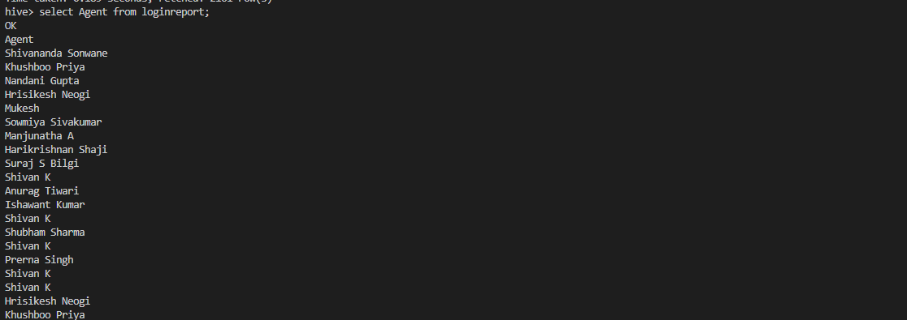

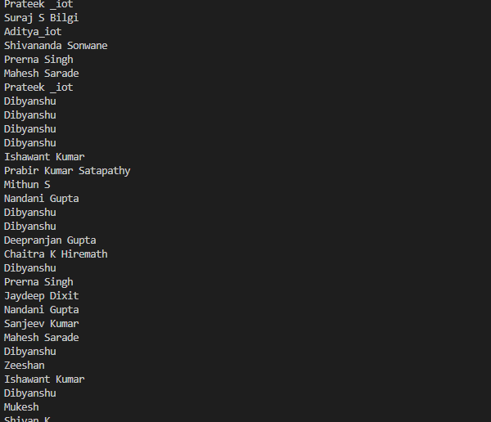

4. Find out agent average rating

select Avg_rating from AgentPerfromance;

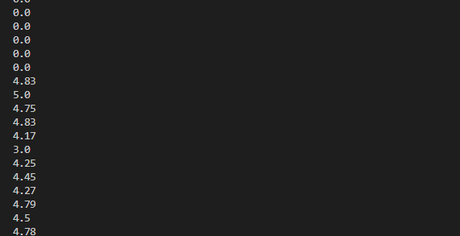

5. Total working days for each agents

select Agent as name, count(distinct date_dd) as total_working_Days from LoginReport group by Agent;

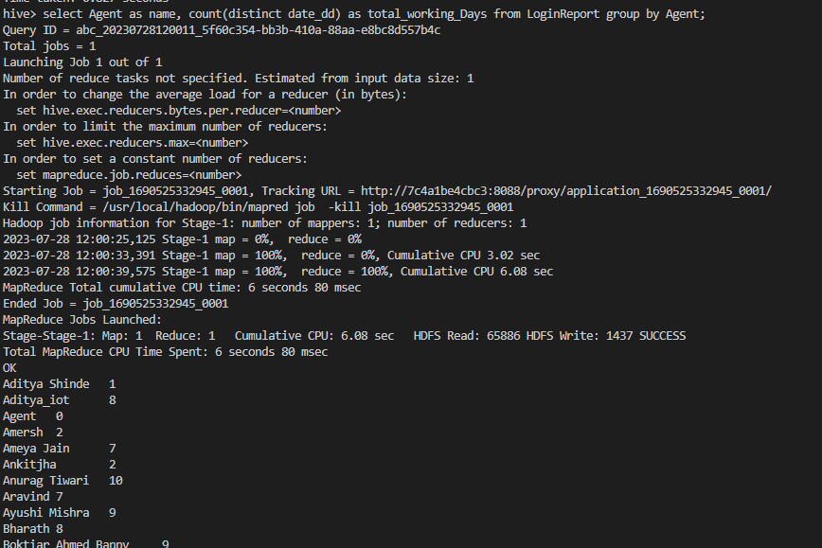

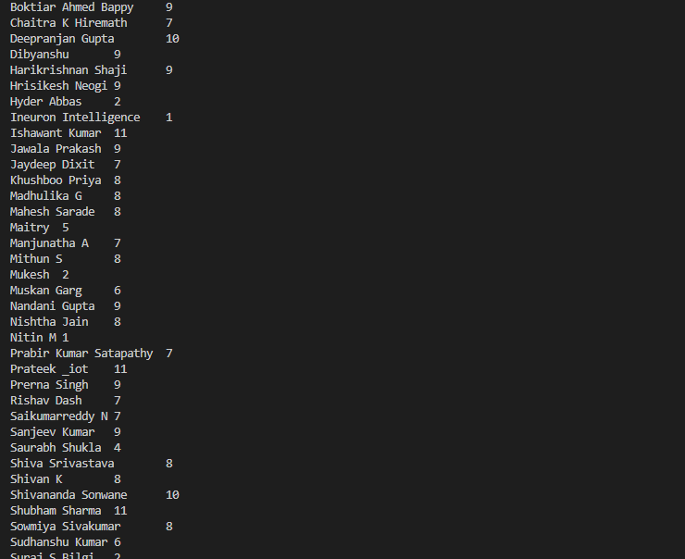

6. Total query that each agent have taken

select Agent_name as name, sum(Total_chats) as total_query_take from AgentPerfromance group by Agent_name order by total_query_take desc;

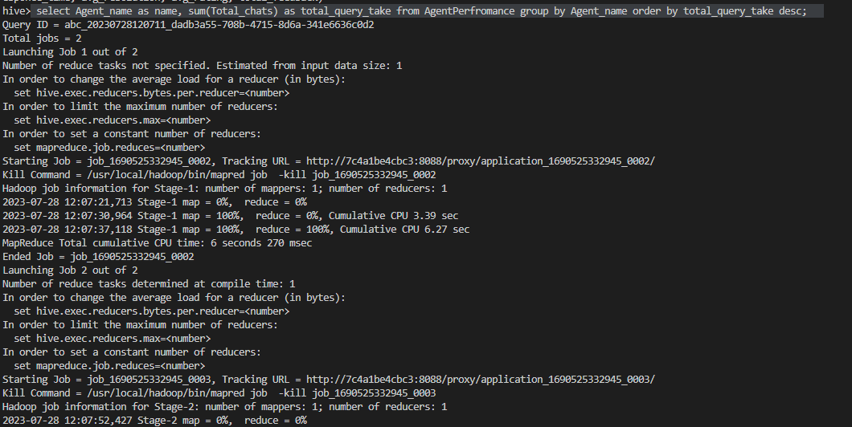

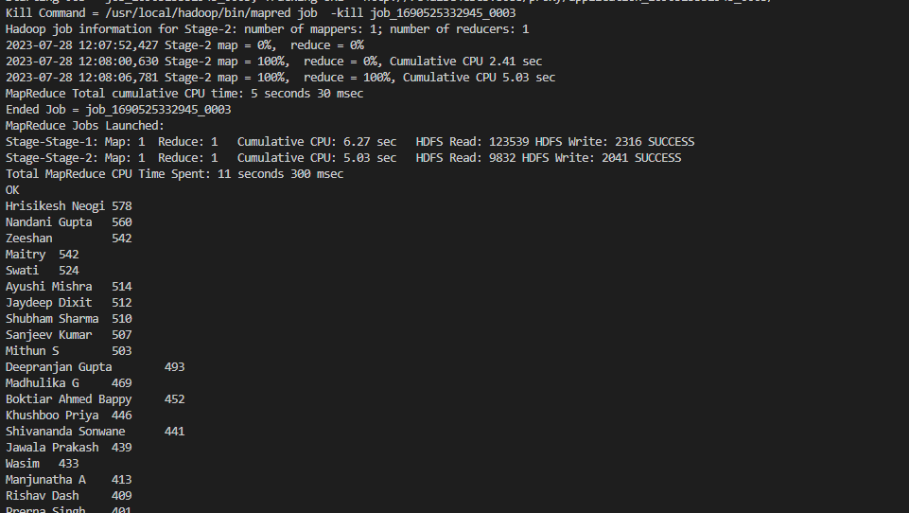

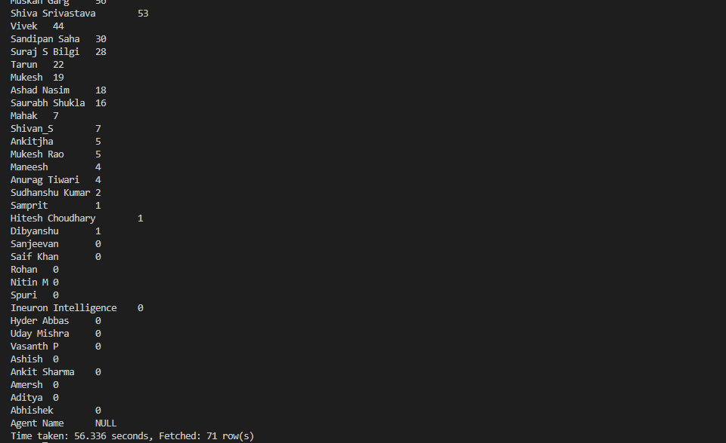

7. Total Feedback that each agent have received

select Agent_name as name, sum(total_feedback) as total_feedback_taken from AgentPerfromance group by Agent_name order by total_feedback_taken desc;

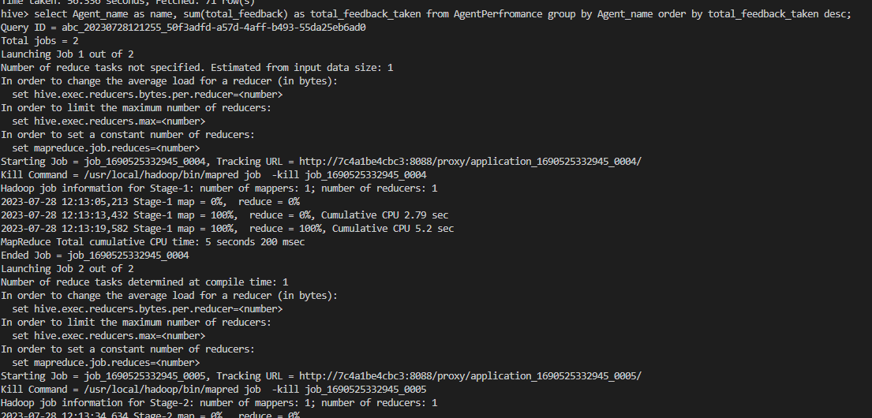

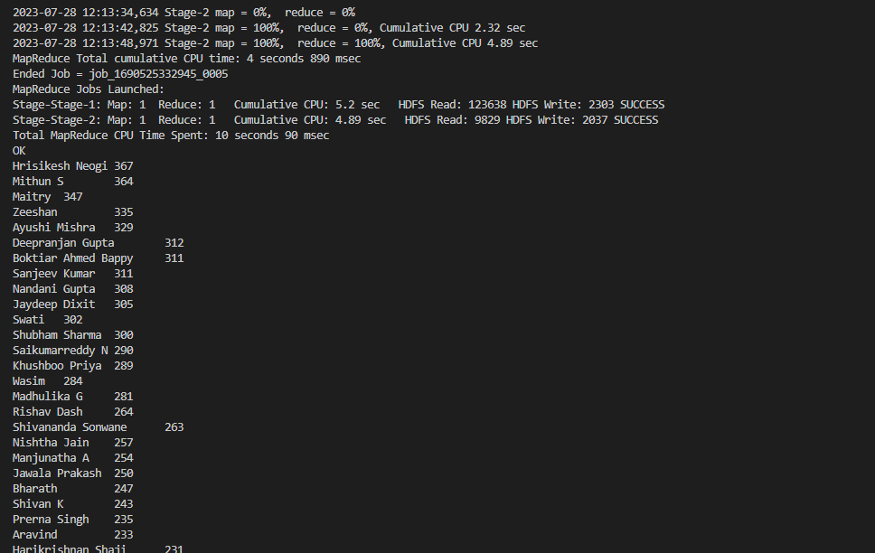

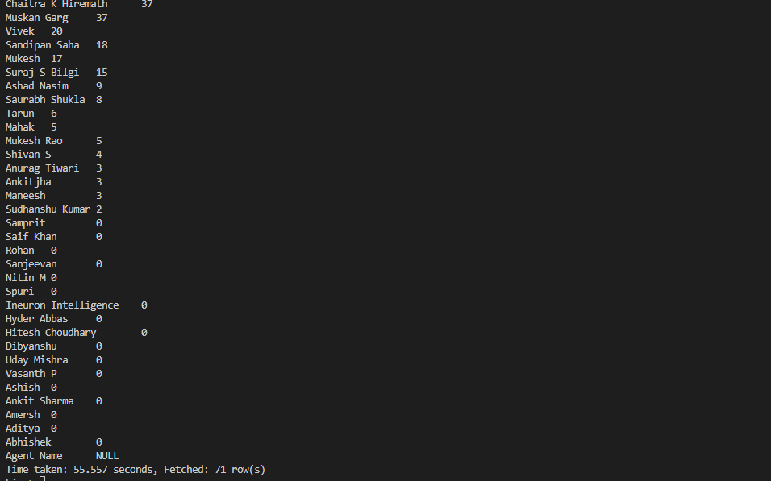

8. Agent name who have average rating between 3.5 to 4

select Agent_name from AgentPerfromance where Avg_rating BETWEEn 3.5 and 4;